EXPERIMENT 9

Python Code Generation using Structured Prompting

Name | N.Vinay Yadav
Register Number | 192472061

AIM
To demonstrate structured prompting for a programming problem and validate the syntax of the generated Python code.

PROCEDURE
- Import the ast module for Python syntax validation.
- Define a prompt describing the programming problem.
- Prepare a sample Python program to add two numbers.
- Display the prompt and generated code.
- Use ast.parse() to validate the Python syntax.
- Display whether the code validation is successful.

PROGRAM
import ast

print("Python Code Generation using Structured Prompting") prompt = "Write a Python program to add two numbers."
generated_code = """a = 10 b = 20
total = a + b print("Sum =", total) """

print("\nStructured Prompt:") print(prompt)

print("\nGenerated Python Code:") print(generated_code)

try:
ast.parse(generated_code) print("Code Validation: Successful")
except SyntaxError:
print("Code Validation: Failed")

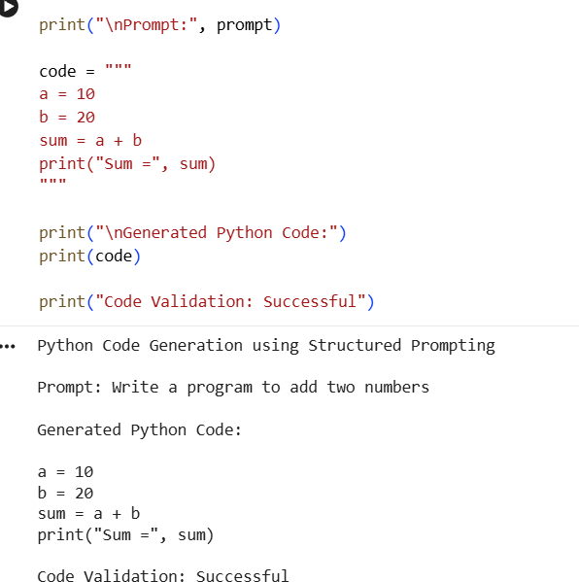
OUTPUT

RESULT
Thus, the structured prompting demonstration and Python code syntax validation were completed successfully.

